**Hawaayein Features and Functionalities**

**Signup Page:**

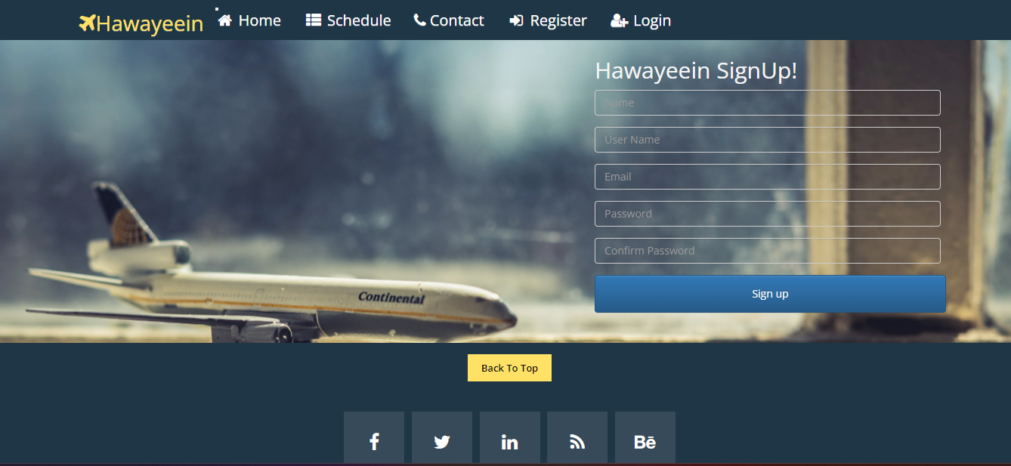

Login Page:

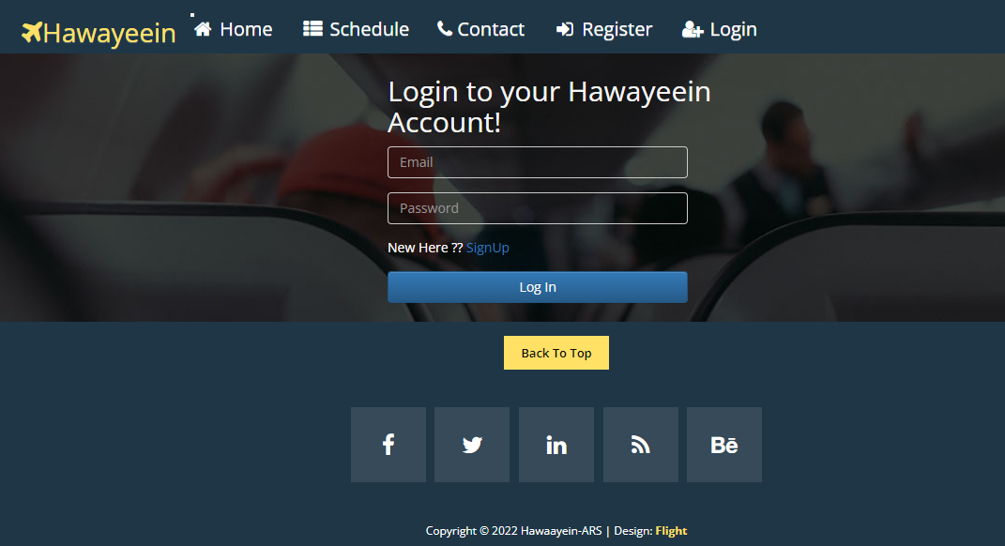

Home page before login:

View Tickets Option is not available

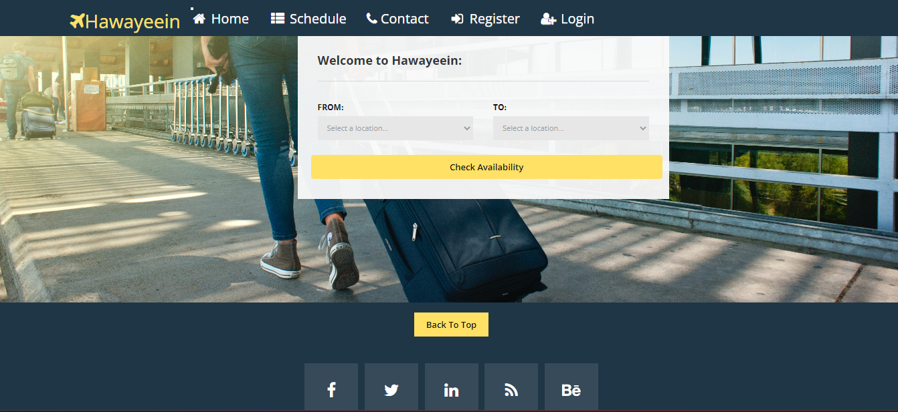

Home page after login:

View Tickets Option is available

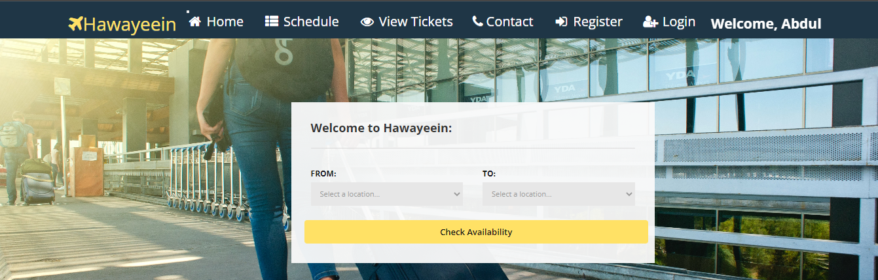

Schedule Page (Every flights data is displayed)

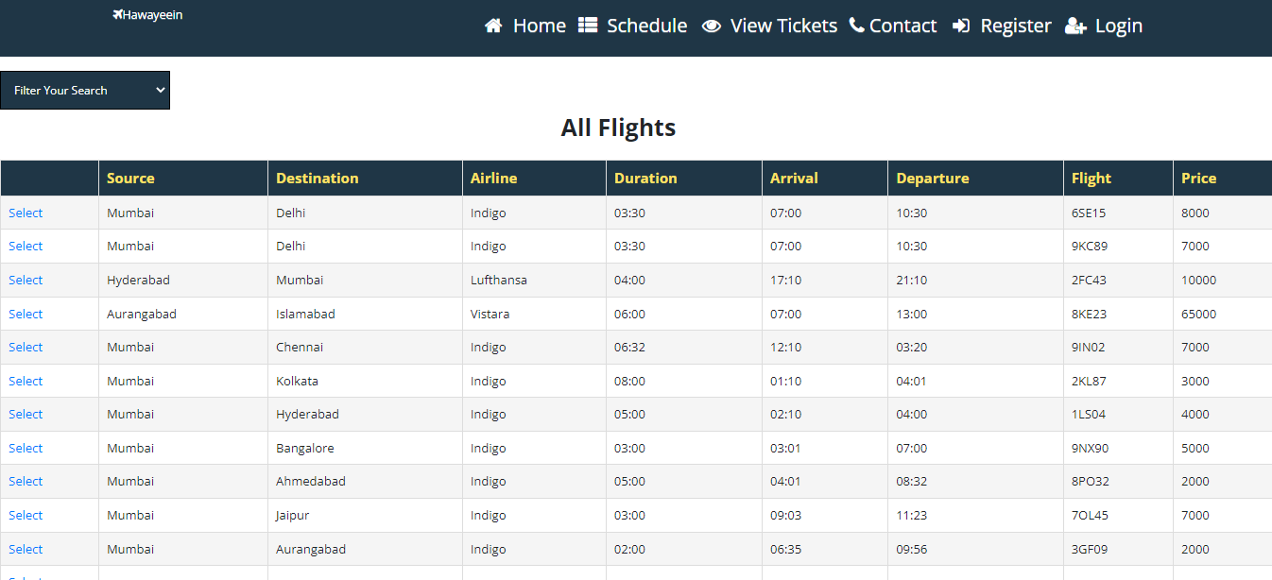

Filter search option (Can Search for only vistara only indigo and cheapest flights available)

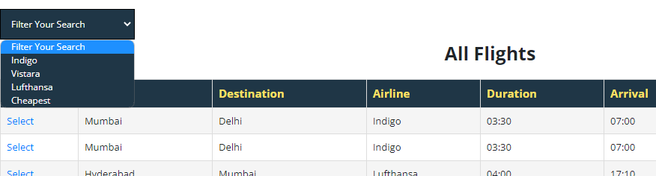

If searched for mumbai to hyderabad

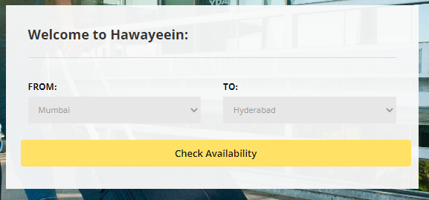

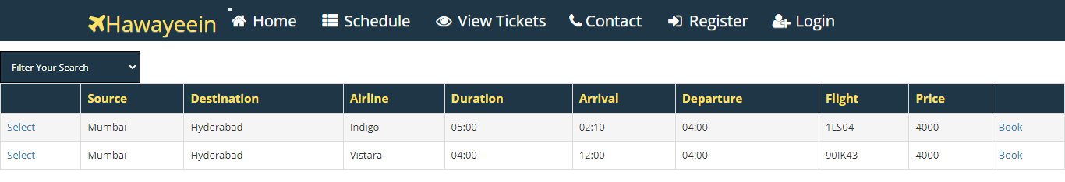

You can book any of the flight

(Lets say Flight 1LS04) 7 seats are left if we book this flight number of flights will also be reduced

So lets book 1 ticket for Mumbai to Hyderabad of flight (1LS04) click on book button beside



When clicked on Book it will ask you to fill details

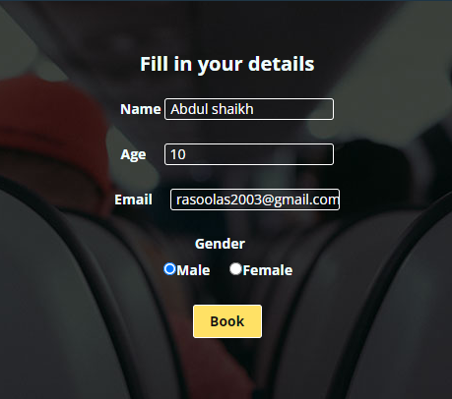

Make sure to enter the right gmail the field is validated and booking id will be sent ot that particular gmail

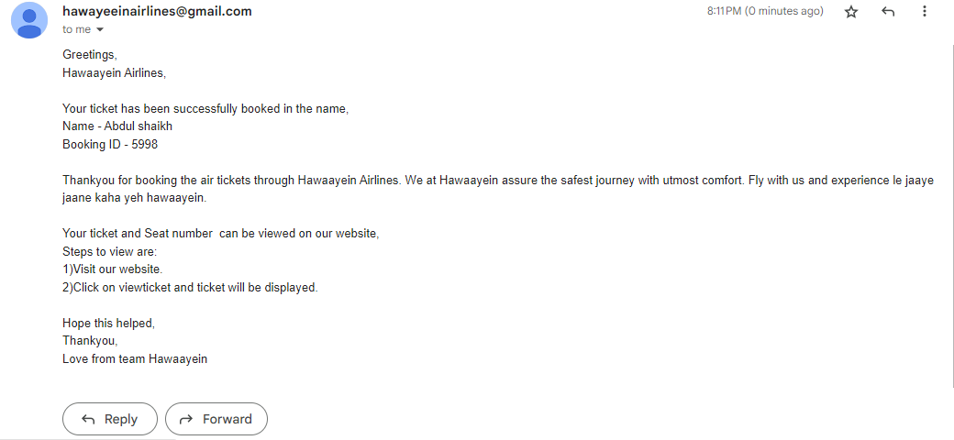

Booking ID will be sent you can view the ticket by the booking ID at the website Booking ID

got = (5998)

Search this booking ID in the View ticket section to get the ticket



Your Ticket

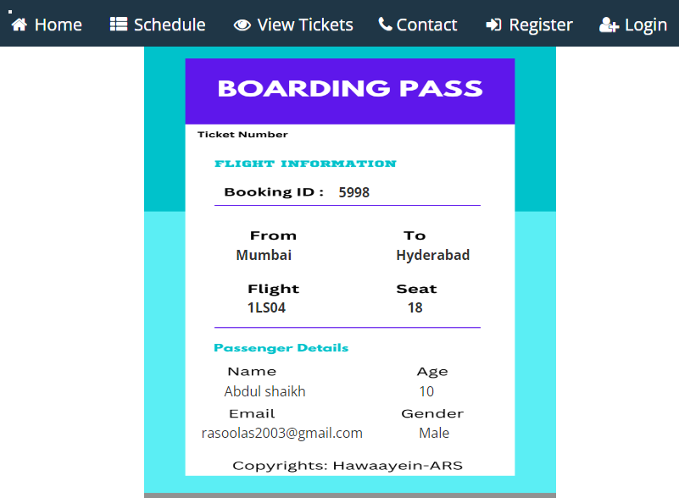

1 seat must be subtracted from the 1LS04 Flight

